Office Helpers Needed
We are seeking students in Grade 5 & 6 to take on the role of Office Helper.

The requirements for this position are listed below. The Learning Skills and Work Habits you will have the opportunity to build and demonstrate are shown in brackets followed by other words in italics that can be used to describe the same work habit.

For example, a coach or volunteer supervisor may have said you are “Reliable” and have good “Teamwork” skills. This is like saying you are “Responsible” and a good “Collaborator”. Knowing different words used to describe work habits can help you relate your school experiences to your experiences outside the classroom.

As an Office Helper, you will also have an opportunity to build and demonstrate your Essential Skills. These skills
are used in work, learning and life. Essential Skills are shown in bold after the work habits.

• Arrive promptly in the office at the beginning of your assigned shift. (Responsibility, Organization, Reliability,
Scheduling or Budgeting and Accounting)

• Be a role model for all students. (Self-Regulation, Responsibility, Initiative, Reliability)

• Check the schedule to ensure that it is your day and double check who your partner is. (Document Use)

• Review the notes in the duotang to ensure that you familiarize yourself with all the office routines and procedures at the very beginning of your shift. (Responsibility, Initiative, Reading Text)
• Check in with the secretary to determine if there are any “special jobs” to be completed. (Initiative, Collaboration, Self-Regulation, Organization, Teamwork, Working Independently, Oral Communication)
• Estimate how long each job will take so you have enough time to complete the tasks. (Organization, Numerical
Estimation)

• Remember that you are representing our school each time you answer the phone or greet a visitor, student or teacher. Be friendly and polite at all times. (Self-Regulation, Initiative, Customer Service, Oral Communication)
• Answer the phone promptly and professionally when it rings, using the script provided. (Responsibility,
Independent Work, Customer Service, Reliability, Oral Communication, Reading Text)

• Decide how to respond to a phone inquiry:

• Put the call on hold and page the staff member using the Public Address System;

• Write down a message using the template provided;

• Call to the appropriate classroom to relay a message;

• Call for assistance (Secretary, Principal or Vice-Principal)

(Organization, Responsibility, Collaboration, Independent Work, Reliability, Teamwork, Customer Service,
Decision Making, Oral Communication, Document Use)

• Respond to questions from visitors and call for the appropriate person to assist you. (Responsibility, Initiative,
Customer Service, Reliability, Decision Making, Oral Communication)

• Find answers to questions, by asking staff, students or looking up information. (Customer Service, Finding
Information, Oral Communication)

Office Helper - page 2
• Provide ice and/or bandages to students with “minor” injuries. Call an administrator or teacher for assistance. (Responsibility, Reliability, Customer Service, Working Safely, Oral Communication)
• Work collaboratively with your assigned partner to decide the role of each person. (Collaboration, Teamwork,
Decision Making)

• At the end of your shift, touch base with the secretary or administrator to relay any important messages or information. (Responsibility, Organization, Reliability, Oral Communication)
• Find a replacement Office Helper should you be unable to complete one of your shifts. (Responsibility, Initiative,
Reliability)

• As an Office Helper, you work on similar tasks from one day to the next, as described above. You use your experience and guidance from others to decide which tasks should be completed before others. When you have to share materials or equipment with your partner, you can work with him/her to figure out who will get to use the equipment first. Follow the office procedures and routines and be ready to respond to interruptions, like phone calls, and then return to complete your tasks. (Responsibility, Reliability, Collaboration, Teamwork, Job Task Planning and Organizing)

You can transfer your Essential Skills and work habits to everyday life or the next place you go – whether it’s
further education, training or the workplace. More information on how you use your Essential Skills and work habits in everyday life is on the Ontario Skills Passport website.
Identifying and reflecting on the Essential Skills and work habits you demonstrate as an Office Helper will help you develop your “All About Me” portfolio as you answer the four education and career/life planning inquiry questions: Who am I? What are my opportunities? Who do I want to become? What is my plan for achieving my goals?

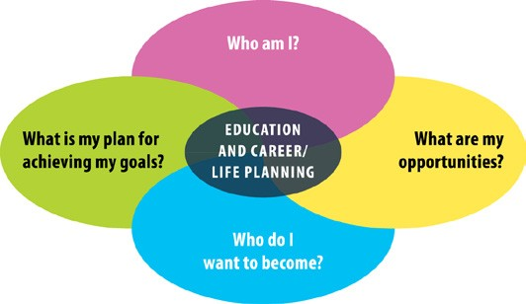
ontario.ca/skillspassport

